Email: patents@cumail.in
INSTRUCTIONS:
- Go to File → Download → Microsoft Word (.docx)
- Download the IDF in your local storage.
- Explain your invention comprehensively in the form.
- Save your IDF file with the name of the Title of your invention. e.g.: "A Smart Electric Kettle".
- Upload the duly filled IDF below.
INVENTOR DETAIL:
NAME: | Mohammad Saood
GENDER: | Male
EMAIL: | saoodvision@gmail.com
MOBILE NO: | 8750737014
DEPARTMENT: | Computer Science & Engineering (AI & ML)
DESIGNATION: | M.E. 1st Year Student
SCANNED HAND SIGNATURE: | [Attach scanned signature]
OTHER INVENTOR DETAIL:
NAME: | Mayank Yadav
GENDER: | Male
EMAIL: | mayaank@gmail.com
MOBILE NO: | 8750737014
DEPARTMENT: | Computer Science & Engineering (AI & ML)
DESIGNATION: | M.E. 1st Year Student
SCANNED HAND SIGNATURE: | [Attach scanned signature]
A) Please enlist the Key concepts and terms / Keywords / Synonyms used in the Invention.
S. No | Keywords for invention which has to be searched | Synonyms
1 | Wearable health band | Smart band; fitness tracker; smartwatch; wrist wearable
2 | Multi-agent AI system | AI council; agent panel; ensemble of agents; committee of models
3 | Specialist agent | Domain expert model; physiology / context / behaviour / goals agent
4 | Agent deliberation / debate | Machine reasoning; argumentation; structured disagreement
5 | Consensus gating | Agreement threshold; quorum; confidence gate; decision release rule
6 | Explainable recommendation | Transparent 'why'; rationale; justification; reasoned advice
7 | Context-aware personalisation | Situation awareness; goal-aligned coaching; adaptive nudging
1. TITLE OF INVENTION (15 words max)
Second Chair: A Wearable Health Band with a Deliberating Council of Specialist AI Agents
(Alternative titles: “The Quorum”, “Not So Fast” — a consensus-gated wearable advisor.)
2. PROBLEM STATEMENT & BACKGROUND
Explain the real-life problem your invention solves. Avoid technical jargon.
Problem Statement:
Millions of people wear fitness bands and smartwatches to make better daily decisions about their health, money, and time — for example whether to eat that burger, skip the gym, go to bed, or take a break. But today’s wearables only show raw numbers (“heart rate 92, 6,000 steps”) and a single, one-size-fits-all tip (“stand up”, “breathe”). That single suggestion is generated by one fixed rule or model that does not weigh the many, often conflicting, sides of a real-life situation. It does not know that the user is stressed, running late, behind on a weight-loss goal, and out with friends all at the same time. As a result the advice is generic, easy to distrust, and easy to ignore — and users cannot see why a recommendation was made, so they cannot judge whether to follow it. Everyone who relies on a wearable to change a habit (dieting, saving money, sleeping better, managing stress or a chronic condition) faces this gap between ‘lots of data’ and ‘one decision I can actually trust’.
Existing Solutions / Prior Methods (if known):
Current products and methods used to address this problem, and why they fall short:
- Mainstream wearables (Apple Watch, Fitbit, Garmin, Samsung) — show data and a single threshold-based alert, but give one flat suggestion with no reasoning and no awareness of the user’s wider context or goals.
- Single-model AI coaching apps — use one recommender model / rule engine; a single model can be confidently wrong and offers no internal ‘second opinion’ or check before advising.
- Academic ensemble / multi-agent debate methods — research on multi-agent and ‘society of mind’ systems and LLM debate improves answer quality, but has not been packaged on-device for a wearable that gates advice on genuine, reasoned consensus.
- Context-aware reminder apps — rule-based nudges (calendar/context reminders) do not reconcile conflicting objectives (health vs. mood vs. budget) and never explain the trade-off.
None of these convene multiple specialist viewpoints that argue about the user’s situation and then release a single recommendation only when they truly agree for the right reasons, together with a short, transparent explanation.
3. OBJECTIVE OF THE INVENTION
- To move a wearable from showing data and one flat tip to delivering a single, trustworthy decision produced by several specialist AI agents.
- To make each recommendation context-aware and goal-aligned by combining physiology, situation, habits, and the user’s stated goals.
- To release advice only when the agents reach genuine consensus for sound reasons, and otherwise stay silent or ask one clarifying question.
- To make every recommendation explainable by attaching a short ‘why’ so the user can trust and act on it.
- To run privately and efficiently on/near the band so personal data is protected.
INVENTION DETAILS
Describe your invention as if you are explaining it to a non-technical administrator.
Summary of the Invention:
The invention is a wearable health band, ‘Second Chair’, that does not just track the user — it convenes a panel (a ‘council’) of specialist AI agents that each look at the user’s current situation from a different angle, discuss and argue about it, and then tell the user the single best decision — but only when they truly agree, and for the right reasons. Instead of one flat suggestion from one model, the band acts like a wise ‘second chair’ sitting beside the user who quietly says ‘hang on, think about this’. Four specialist agents — a Physiology agent (heart rate, sleep, glucose, stress), a Context agent (place, time, calendar, weather, who you are with), a Behaviour/Habit agent (what you usually do and what you have done today), and a Goals agent (what you said you want — lose weight, save money, sleep more) — form their own opinions and debate them (for example, ‘recommend the burger’ vs. ‘you are stressed and behind on your goal’). A deliberation engine reconciles the arguments and an agreement gate releases one recommendation with a short explanation only when there is well-reasoned consensus; otherwise the band stays quiet or asks a single question. This solves the stated problem by turning ‘lots of data’ into one decision the user can understand and trust.
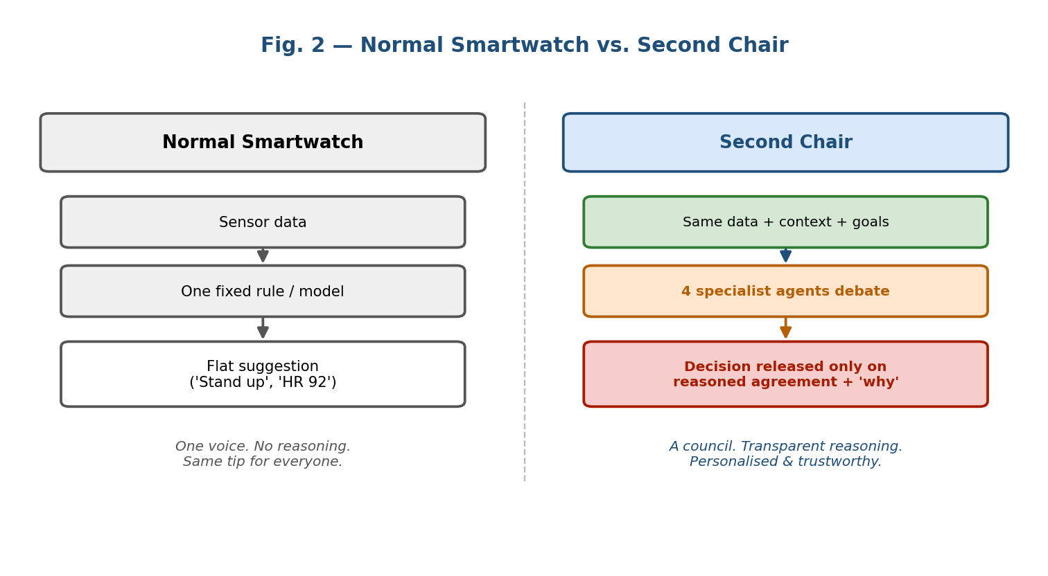
Fig. 2 — A normal smartwatch gives one flat tip; Second Chair convenes a council and releases a reasoned, consensus-gated decision.
Technical Description – How it Works (step-by-step):
The working is described in the order: input / starting material → key components → processing / interaction → output / final result.
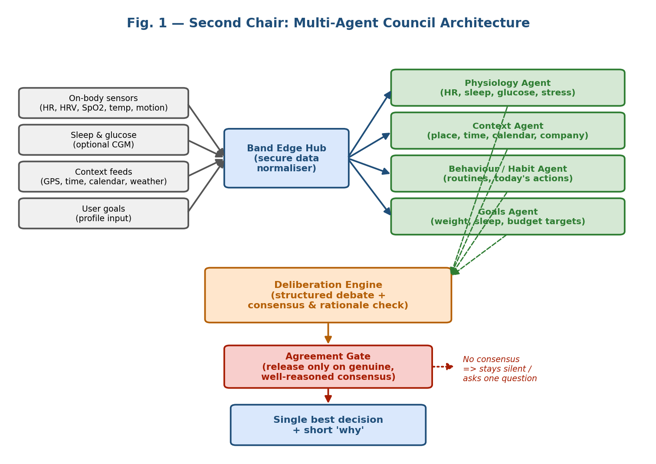
Fig. 1 — System architecture: sensors and context feed an edge hub, four specialist agents deliberate, and an agreement gate releases a single explained decision.
Input / starting material:
- On-body sensor signals: heart rate, heart-rate variability, SpO₂, skin temperature, and motion/steps from the band.
- Physiological extensions: sleep stages and, optionally, glucose from a paired continuous glucose monitor (CGM).
- Context feeds: GPS location, time of day, calendar events, weather, and (with permission) who the user is with.
- User goals: what the user said they want — e.g. lose weight, save money, sleep more — captured once in a profile and updated over time.
Key components / parts of the device and their functionality:
- (a) Sensor array — wristband housing the sensors listed above; captures the raw signals.
- (b) Band Edge Hub — an on-band secure module that cleans, time-aligns and normalises all signals and context into one ‘situation snapshot’, and protects private data.
- (c) Council of specialist agents — four specialist AI agents, each reasoning only from its own angle: Physiology (HR, sleep, glucose, stress), Context (place, time, calendar, weather, company), Behaviour/Habit (usual routines and today’s actions), and Goals (the user’s stated targets). Each produces its own recommendation with reasons.
- (d) Deliberation engine — lets the agents exchange and challenge each other’s recommendations (argue: e.g. ‘recommend the burger’ vs. ‘you are stressed and behind on your goal’), surfacing evidence and resolving conflicts.
- (e) Agreement gate — checks whether the agents have reached genuine agreement for sound reasons (not a shallow or coincidental match); only then is a decision released.
- (f) Output & explanation module — delivers the single best decision plus a short ‘why’ on the band screen / companion app; if there is no consensus it stays silent or asks one question.
Processing / interaction between components (software flow):
- Capture — the band continuously collects physiology, context, behaviour and goal signals.
- Distribute — the Band Edge Hub builds one normalised situation snapshot and passes it to all four agents.
- Assess — each specialist agent independently forms its own recommendation and the reasons behind it.
- Debate — the deliberation engine lets the agents argue, cite evidence, and counter one another until positions stabilise.
- Gate — the agreement gate evaluates whether there is genuine, well-reasoned consensus.
- Decide — if YES, the band shows one recommendation with a short explanation; if NO, it stays silent or asks a single clarifying question.
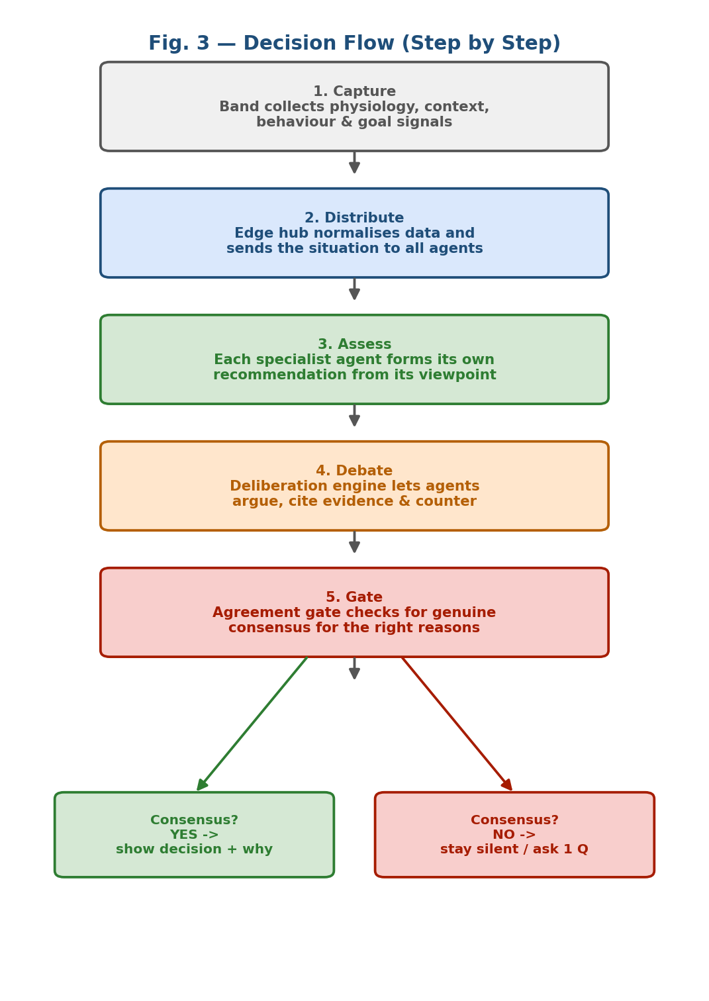
Fig. 3 — Step-by-step decision flow, from signal capture to a consensus-gated, explained recommendation.
Output / final result:
A single, trustworthy recommendation shown at the right moment (e.g. ‘Skip the burger tonight — you’re stressed and behind on your weight goal; have the grilled wrap instead’) together with a short, plain-language ‘why’. When the council does not genuinely agree, the band deliberately says nothing or asks one clarifying question rather than pushing a low-confidence tip.
***Note:
This invention is software embedded within a wearable device. Figures 1 and 3 show, step-wise, how the software (edge hub → agents → deliberation → agreement gate → output) works together with the band hardware and each part’s functionality.
NOVEL ASPECTS OF THE INVENTION
Clearly state what is new compared to existing solutions.
- Council instead of a single voice: a wearable that runs multiple specialist AI agents which independently assess the same situation from physiology, context, behaviour and goals — rather than one fixed rule or single model.
- Structured agent debate on-device: the agents actively argue and challenge each other’s recommendations, surfacing the real trade-offs in a decision, packaged for a resource-constrained wearable.
- Consensus-gated release for the right reasons: a novel agreement gate that releases a recommendation only when the agents genuinely agree with sound, non-coincidental reasoning — and otherwise stays silent or asks one question. This ‘earn-the-right-to-advise’ rule is the key inventive step.
- Built-in explainability: every released decision carries a short ‘why’ derived from the winning arguments, unlike the opaque single tips of current bands.
- Goal-aligned, context-aware reconciliation: conflicting objectives (health vs. mood vs. budget vs. social context) are explicitly reconciled before advising.
Advantages
Advantages | Yes / No
Cost effective | Yes
Improved efficiency | Yes
Eco-friendly | Yes
Higher accuracy | Yes
User-friendly | Yes
Advantages (why should anyone use it?):
- Higher accuracy & trust: combining four expert viewpoints and gating on reasoned consensus produces better, more reliable decisions than one model.
- Improved efficiency: users get one clear, actionable decision instead of raw data plus generic tips they must interpret themselves.
- User-friendly & transparent: a short ‘why’ with every recommendation, and silence when unsure, means fewer annoying, low-value nudges.
- Cost effective: runs on existing band-class hardware with edge processing; no new dedicated hardware and reduced cloud dependence.
- Eco-friendly / privacy-friendly: on-device edge processing lowers continuous cloud data transfer and energy use, and keeps personal data local.
- Personalised: advice is aligned to the user’s own goals and live context, not a one-size-fits-all rule.
6. DRAWINGS OR SUPPORT MATERIAL
The following figures are included in this disclosure:
- Fig. 1 — Multi-agent council system architecture (sensors → edge hub → four specialist agents → deliberation engine → agreement gate → explained output).
- Fig. 2 — Comparison of a normal smartwatch (one flat tip) against Second Chair (reasoned, consensus-gated decision).
- Fig. 3 — Step-by-step decision flowchart from signal capture to consensus-gated recommendation.
(Figures are embedded in Section 3 above and may also be attached separately as high-resolution images.)
7. ABSTRACT (150 words)
A wearable health band, ‘Second Chair’, that turns raw sensor data into a single trustworthy decision. Unlike conventional wearables that display numbers and one flat tip from a single model, the band convenes a council of specialist AI agents — physiology, context, behaviour/habit and goals — that each assess the user’s situation from their own angle. A band edge hub normalises on-body sensor signals, context feeds and stated goals into a situation snapshot shared with all agents. A deliberation engine lets the agents argue and reconcile conflicting recommendations, and an agreement gate releases advice only when they reach genuine consensus for sound reasons, always with a short explanation; otherwise the band stays silent or asks one clarifying question. The result is accurate, context-aware, goal-aligned and explainable guidance that users can understand and trust, delivered efficiently and privately through on-device edge processing.
[Word count: 141]

